Understanding the Cause and Effect
Behind the
Evolutionary Changes of Showcase Business Model

The implications of the recently procured acreage on the scope of the Showcase Development are both tangible and fiscal in nature. However, understanding of this evolution in the business model requires retrospect.
Previously proposed sites for the Showcase with IMAX were as follows:
Option 1:
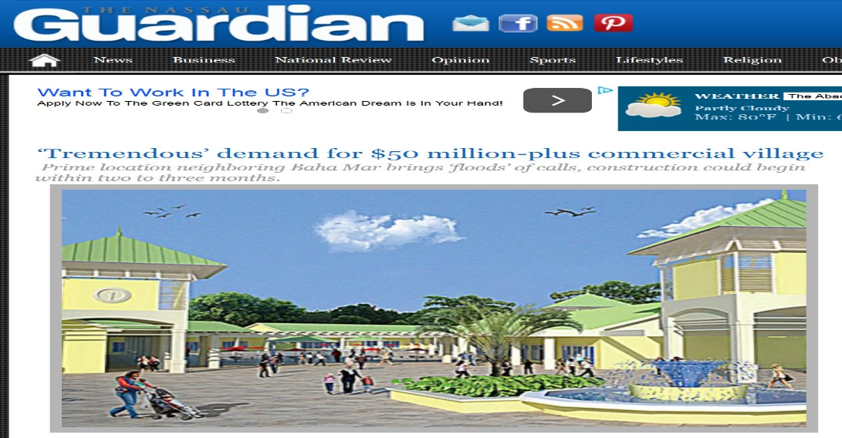
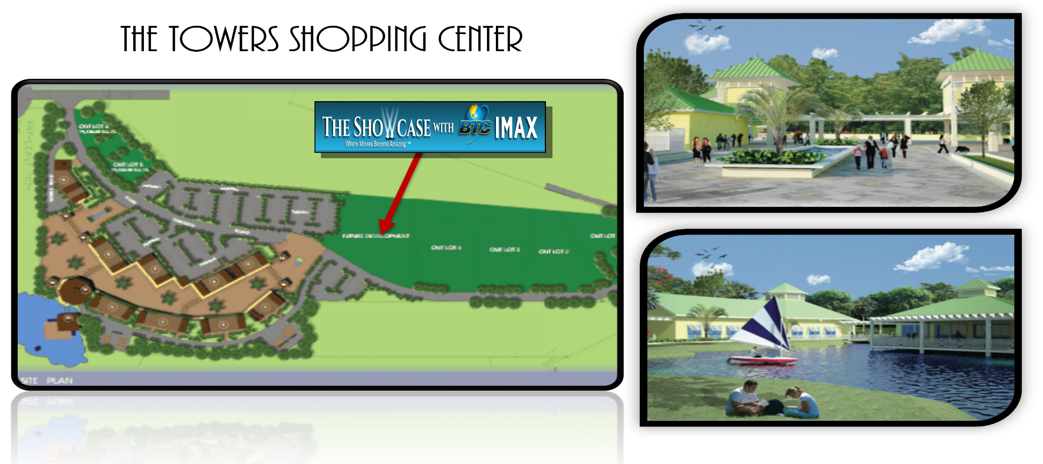
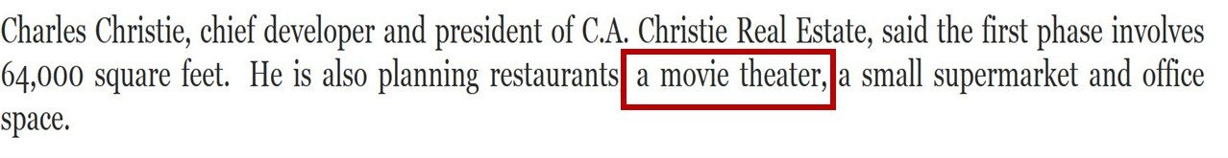The initial site for the project was the Towers Shopping Center on Baha Mar Drive (2012).
Business Model:
- A Cineplex with 7 screens
- Basic Concession Options
- A single feature Attraction: IMAX
Implications to model:
The Showcase was to be nestled in a new shopping development as the anchor attraction. Surrounded by multiple dining options, the cinema would act synergistically with its fellow plaza tenants. This would have provided additional foot traffic to the cineplex.
Outcome:
The Towers Shopping Center (TSC) could not produce the needed documentation for infrastructural development to the Atavus Management team. Hence formal ties to the project were severed. TSC still languishes on Baha Mar Drive undeveloped.
Option 2:
Atavus Group engaged the Government of the Bahamas in November 2013 to secure crown land for the project. After much deliberations and multiple land options, a government official informed Atavus of the likely location: The Sports Center Development
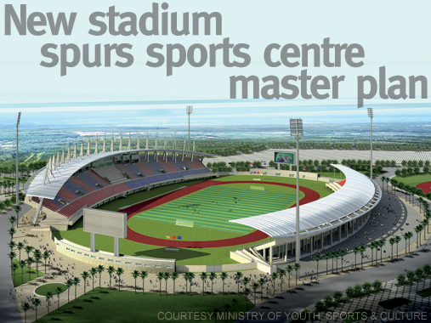
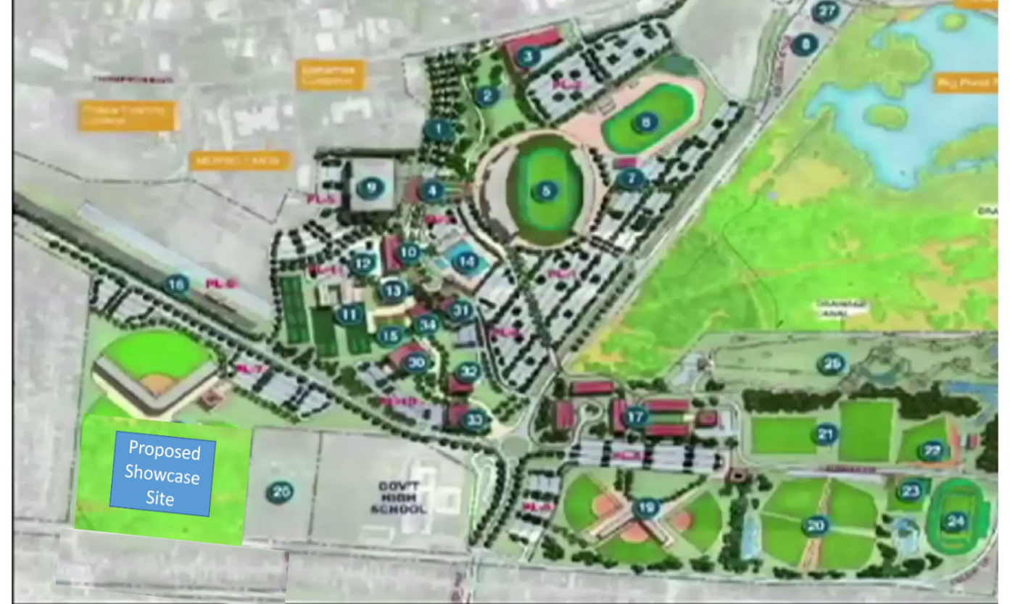
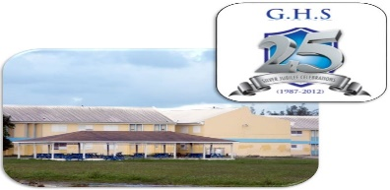

Business Model:
- A Cineplex with 11 screens
- Basic Concession Options
- Feature Attraction: IMAX, 4DX, VIP theater, VIP lounge
Implications to model:
The business model became more aggressive to include more territorial exclusive feature attractions (4DX). This thereby increased the barrier of entry for future competitors. These additions were also included to diversify the customer base.
The Showcase was to be placed next to Government High School (GHS). As part of the Sports Center Master plan, the project was to be one of the centerpiece attractions for the 450 acre development. The potential for foot traffic in the area was incalculable. The cash position of the Atavus Group would also improve because land cost would be more reasonable.
However the negative effects on the project could not be understated:
- Placing the project next to a public school may deter the target high- end clientele while greatly increasing maintenance cost due to vandalism.
- Being minutes away from Yellow Elder, a crime ridden area, increases safety costs immediately.
- Much further distance from Baha Mar, hence impacting the following:
- The Tourist Base would be less likely to venture in the new area vs the first location (TSC)
- Atavus would no longer qualify for concessions from the government because of the distance
- Change in the structure of the building to reflect the lack of a marketable view to sell to the public
- Decrease in the value of the sponsorship program due to the less desirable area.
- That location would have put the facility between both Galleria locations instead of directly next to the western location.
Why is that important?
- Being further away from Galleria West allows that location to stay viable longer. Western customers would no longer have to pass Showcase to get to Galleria West. People love convenience, especially when they are running late. Don’t give them an excuse to stop at the competitor because they are closer. Eastern customers already have that excuse.
- The Geographic strategy of the Showcase is location dependent. Some Hollywood studios dispense movies based on Average Ticket Price (ATP) in an area. Being close to Galleria West allows for this strategy to be employed. In fact, the Sports Center location would have put the Showcase closer to Galleria East. This may have allowed their management the employ said strategy on Showcase.
- Though there is the potential for more foot traffic, the facility is almost a stand- alone entity.

Outcome:
After more than a year of waiting, with no definitive word from the government on the land the Atavus Group re-entered the private market. Shortly thereafter, in November 2014, Atavus Group was informed of the preliminary approval of concessions but denial of the land requested.

Option 3:
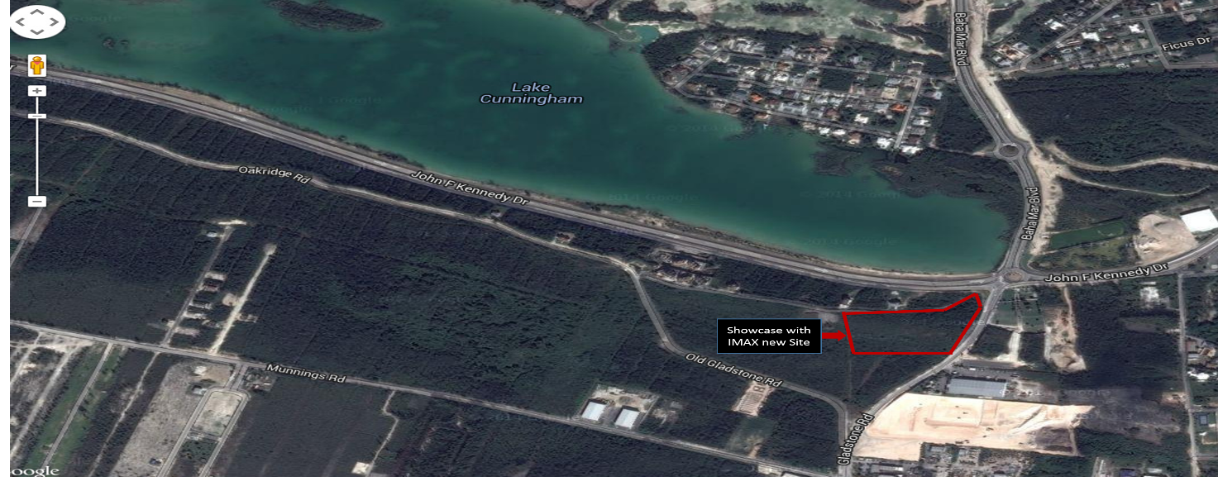
The Final Location of the Showcase with IMAX at the western intersection of Gladstone and JFK.
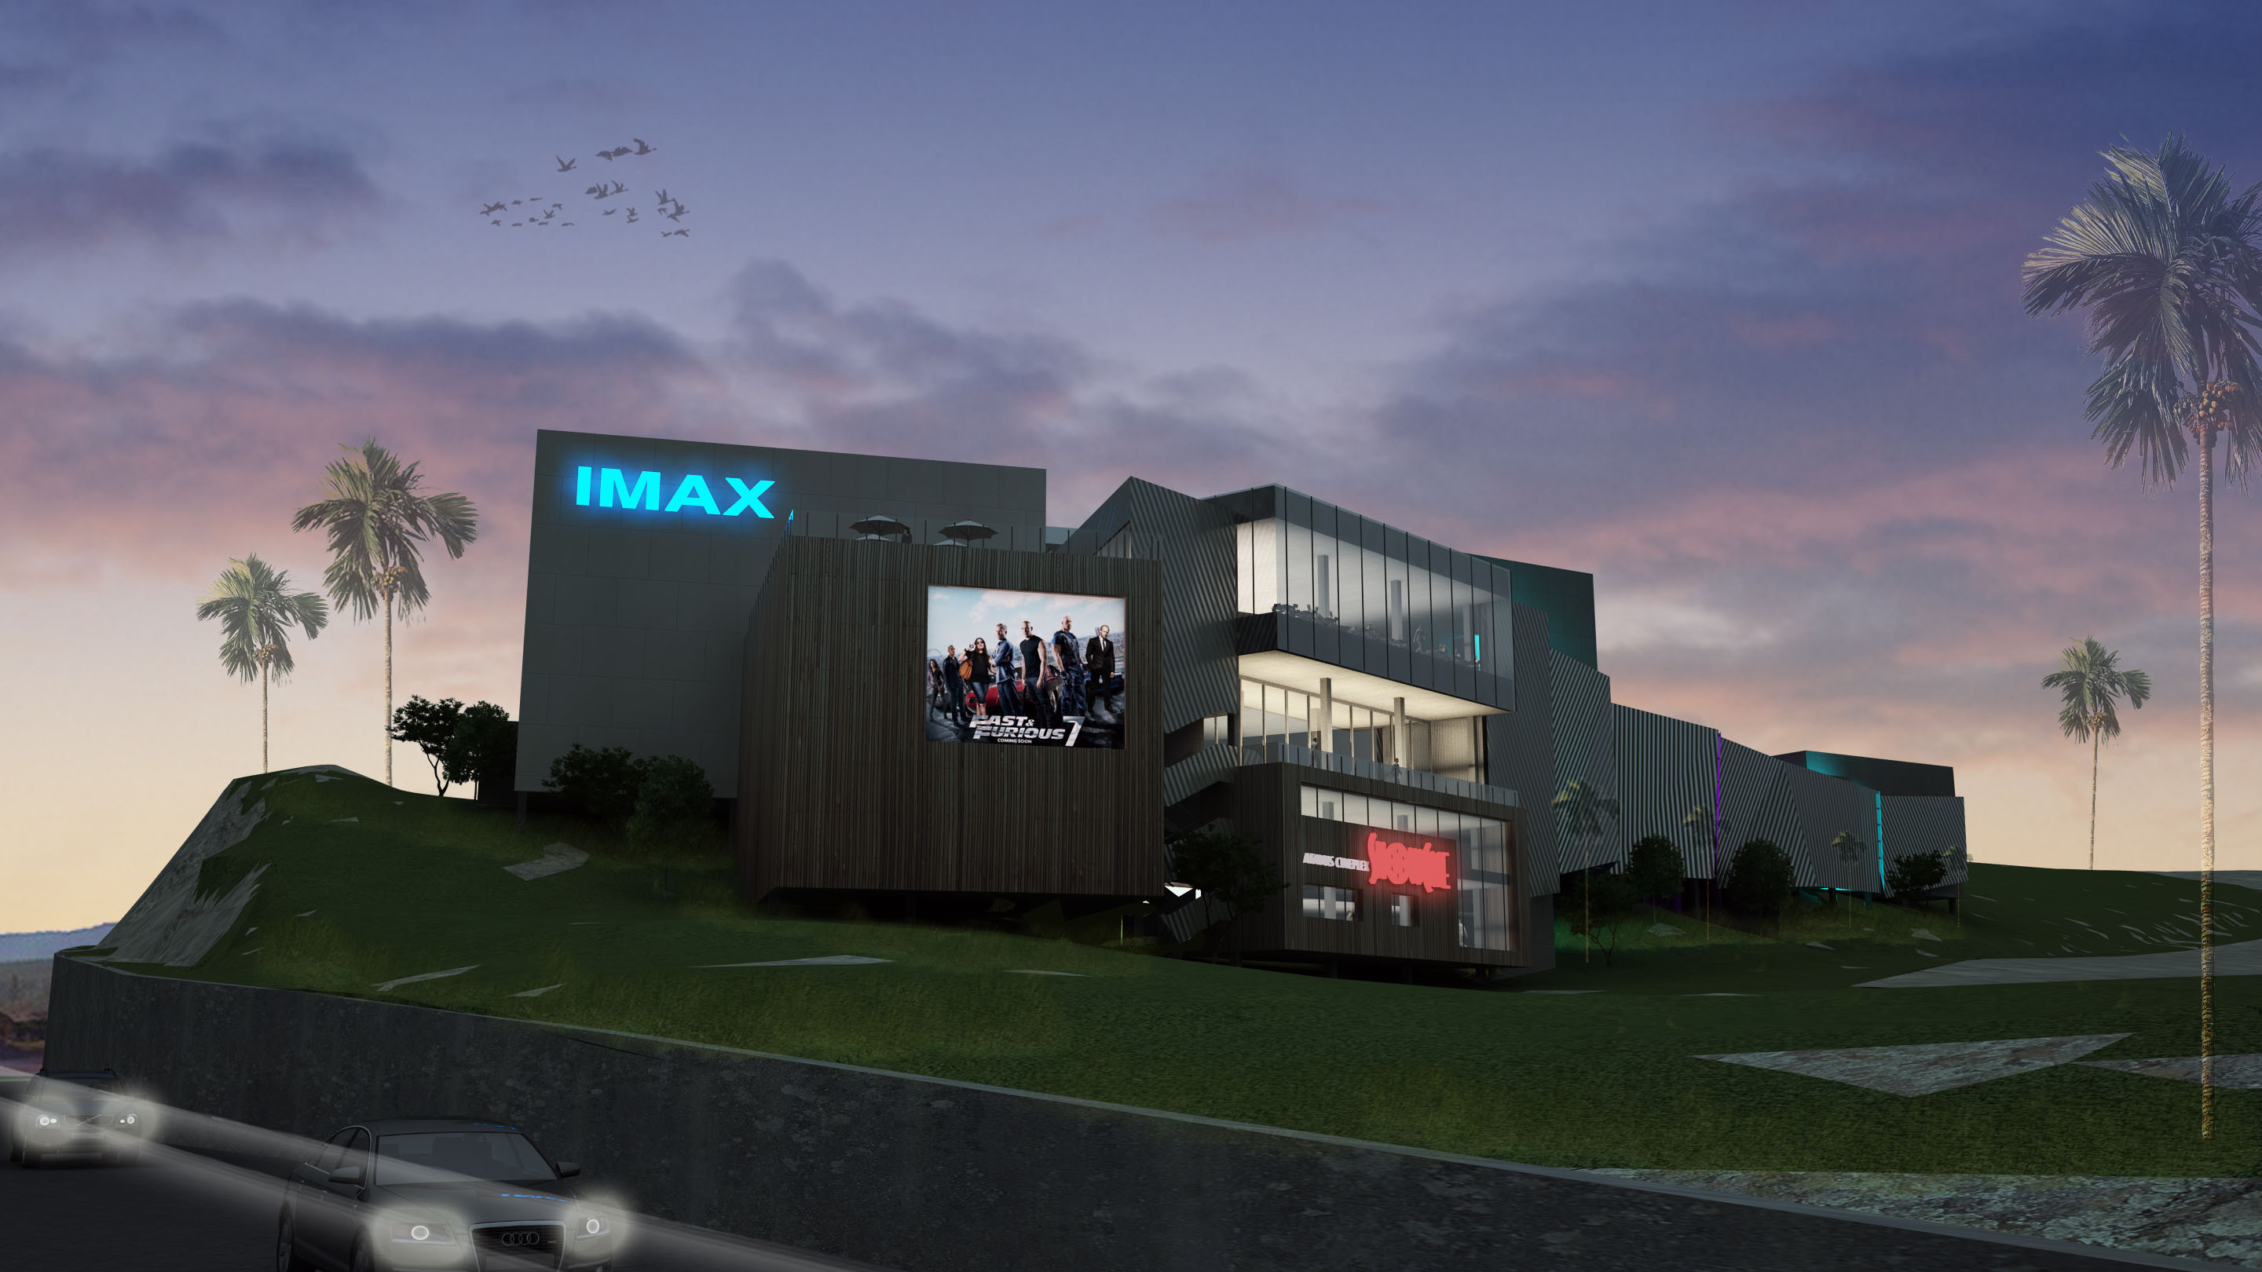

Business Model:
- A Cineplex with 9 screens
- Expanded concessions with ice-cream and coffee
- Full serve restaurant with veranda
- Feature Attractions: IMAX, 4DX, VIP theater, VIP lounge
- Secondary Attractions: Full Arcade, Party Rooms, Kids Indoor Playground
Implications to model:
From logistical and fiscal stand points, this picturesque location overlooking Lake Cunningham, is astounding:
- Great roadside public visibility
- Centrally located
- Minutes from Baha Mar
- Enough real estate (6.5 acres) to fulfill potential of the project
This curbside location puts to rest most of the concerns raised by Option 2. However, building on the top of a hill has brought other considerations that had to be addressed. Notice the robust changes to the business model. Before addressing these alterations, analysis of the cause of the adjustment is in order.
Why are such modifications in order?
As beautiful as the location is, there is no denying the fact that the project is now isolated. Unlike Option1 (the Towers Shopping Center) where other vendors brought foot traffic, there will be no other reason to come to the Showcase with IMAX besides the movies. In year 1and 2 that may not have been a concern, however as the ‘new car smell’ wore off, the cinema’s main customer base would be limited.
With the large initial capital tied up in the project by Atavus, fiscal dexterity would be a challenge for the first few years. Expansion of the business model was in order i.e. a true Family Entertainment Center (FEC) experience.
This approach is essential to maximize the long term viability of the Showcase with IMAX.
To comprehend what happens to a new business when it is isolated and without an appropriate FEC approach, consider the following:

Case study: Mario’s bowling in the ‘Summer Winds Plaza’
Short Term Viability
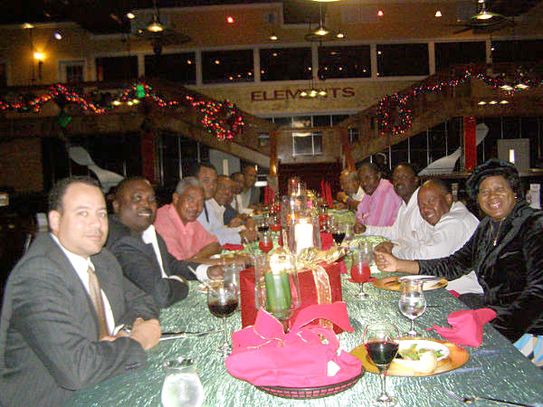
Facts: 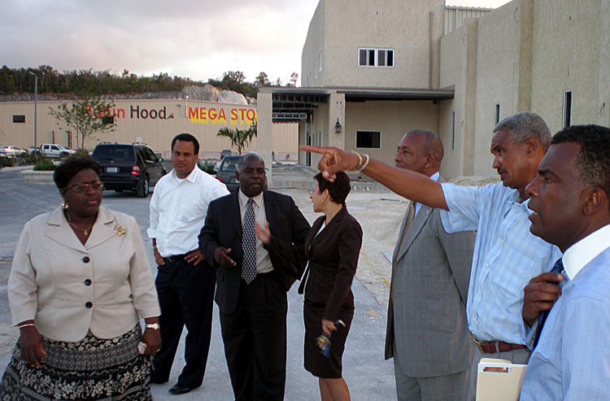Opened 2009 with great political fanfare
- Immediately monopolized the bowling industry of the Bahamas
- Only family entertainment open at night beside the movies.
- Became the ‘It’ spot on the island.

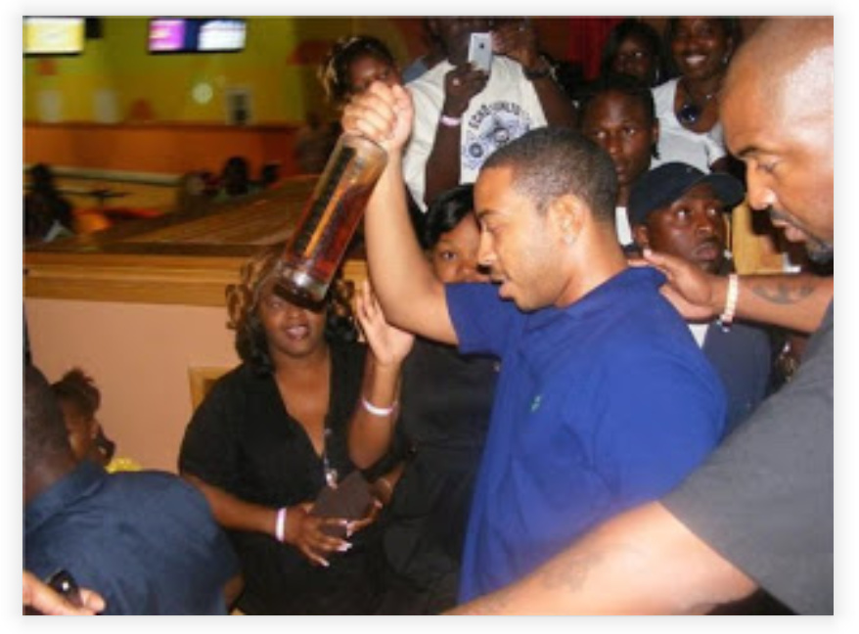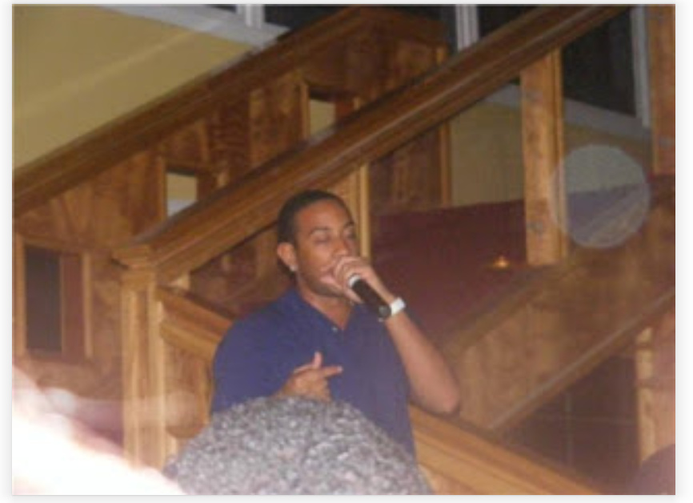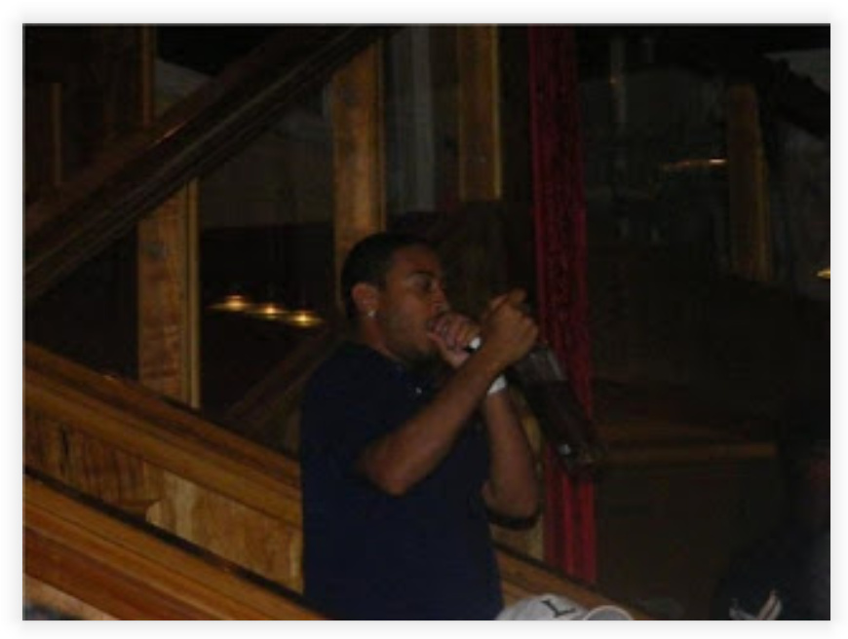

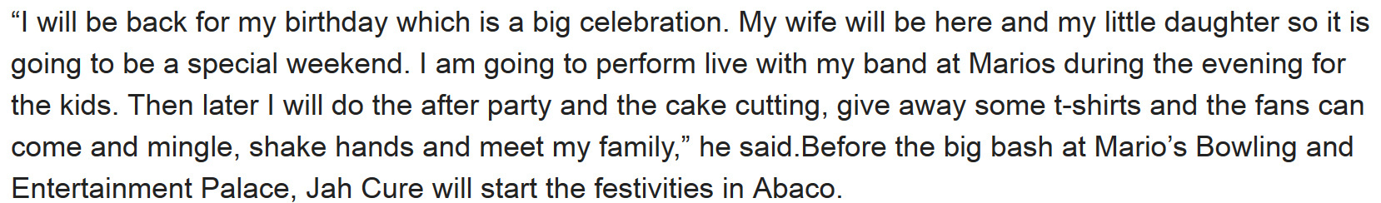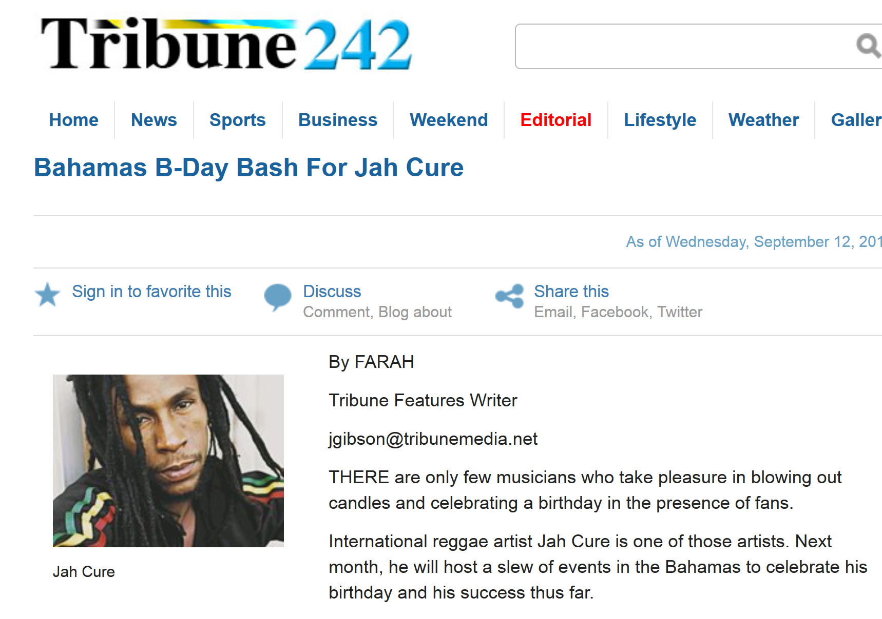

The first three years of business operations were prosperous. However, the fundamental flaws in Mario’s business plan would soon rear their ugly heads.
Long Term Viability
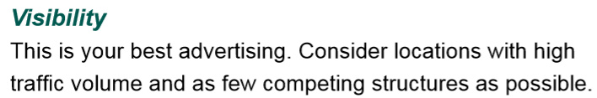According to Brunswick Bowling, the Industry leader, there are several important keys to a successful new Family Entertainment business model (irrespective of the main attraction):

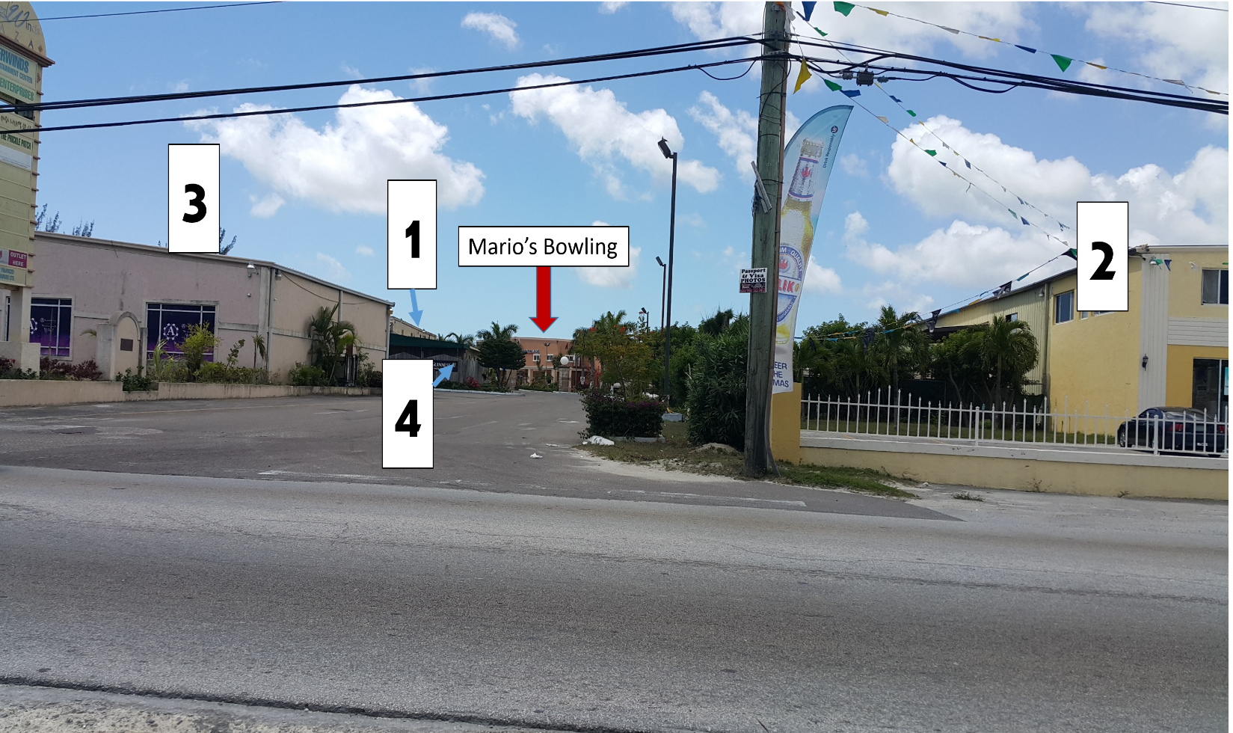
Observe Mario’s bowling interpretation of Visibility with few competing structure.
This lack of roadside visibility would come to haunt Mario’s in a big way later.

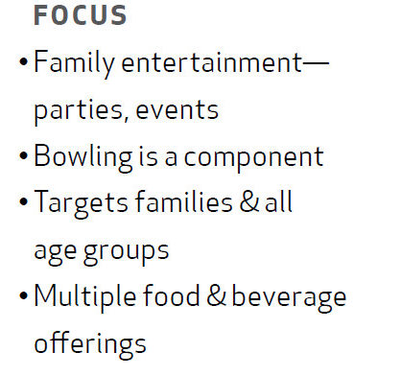Multiple F&B Offerings
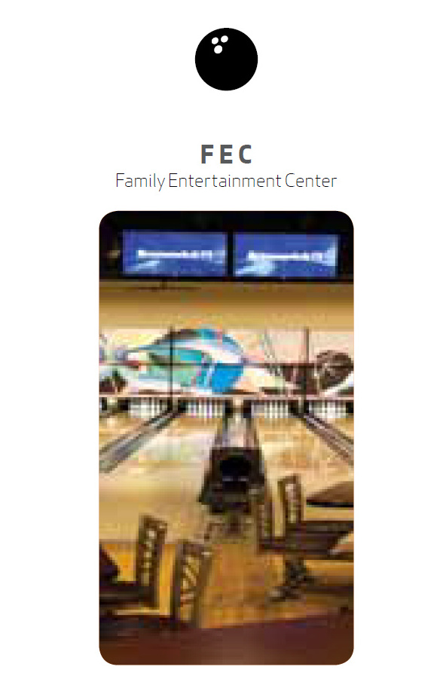
Brunswick states that the second major focus for a Family oriented business model is multiple food and beverage offerings. In a FEC, having numerous choices has been shown to increase attendance and profitability. People DEMAND selections when all of their activities are in the same building. F&B is the second largest component of a FEC’s revenue.

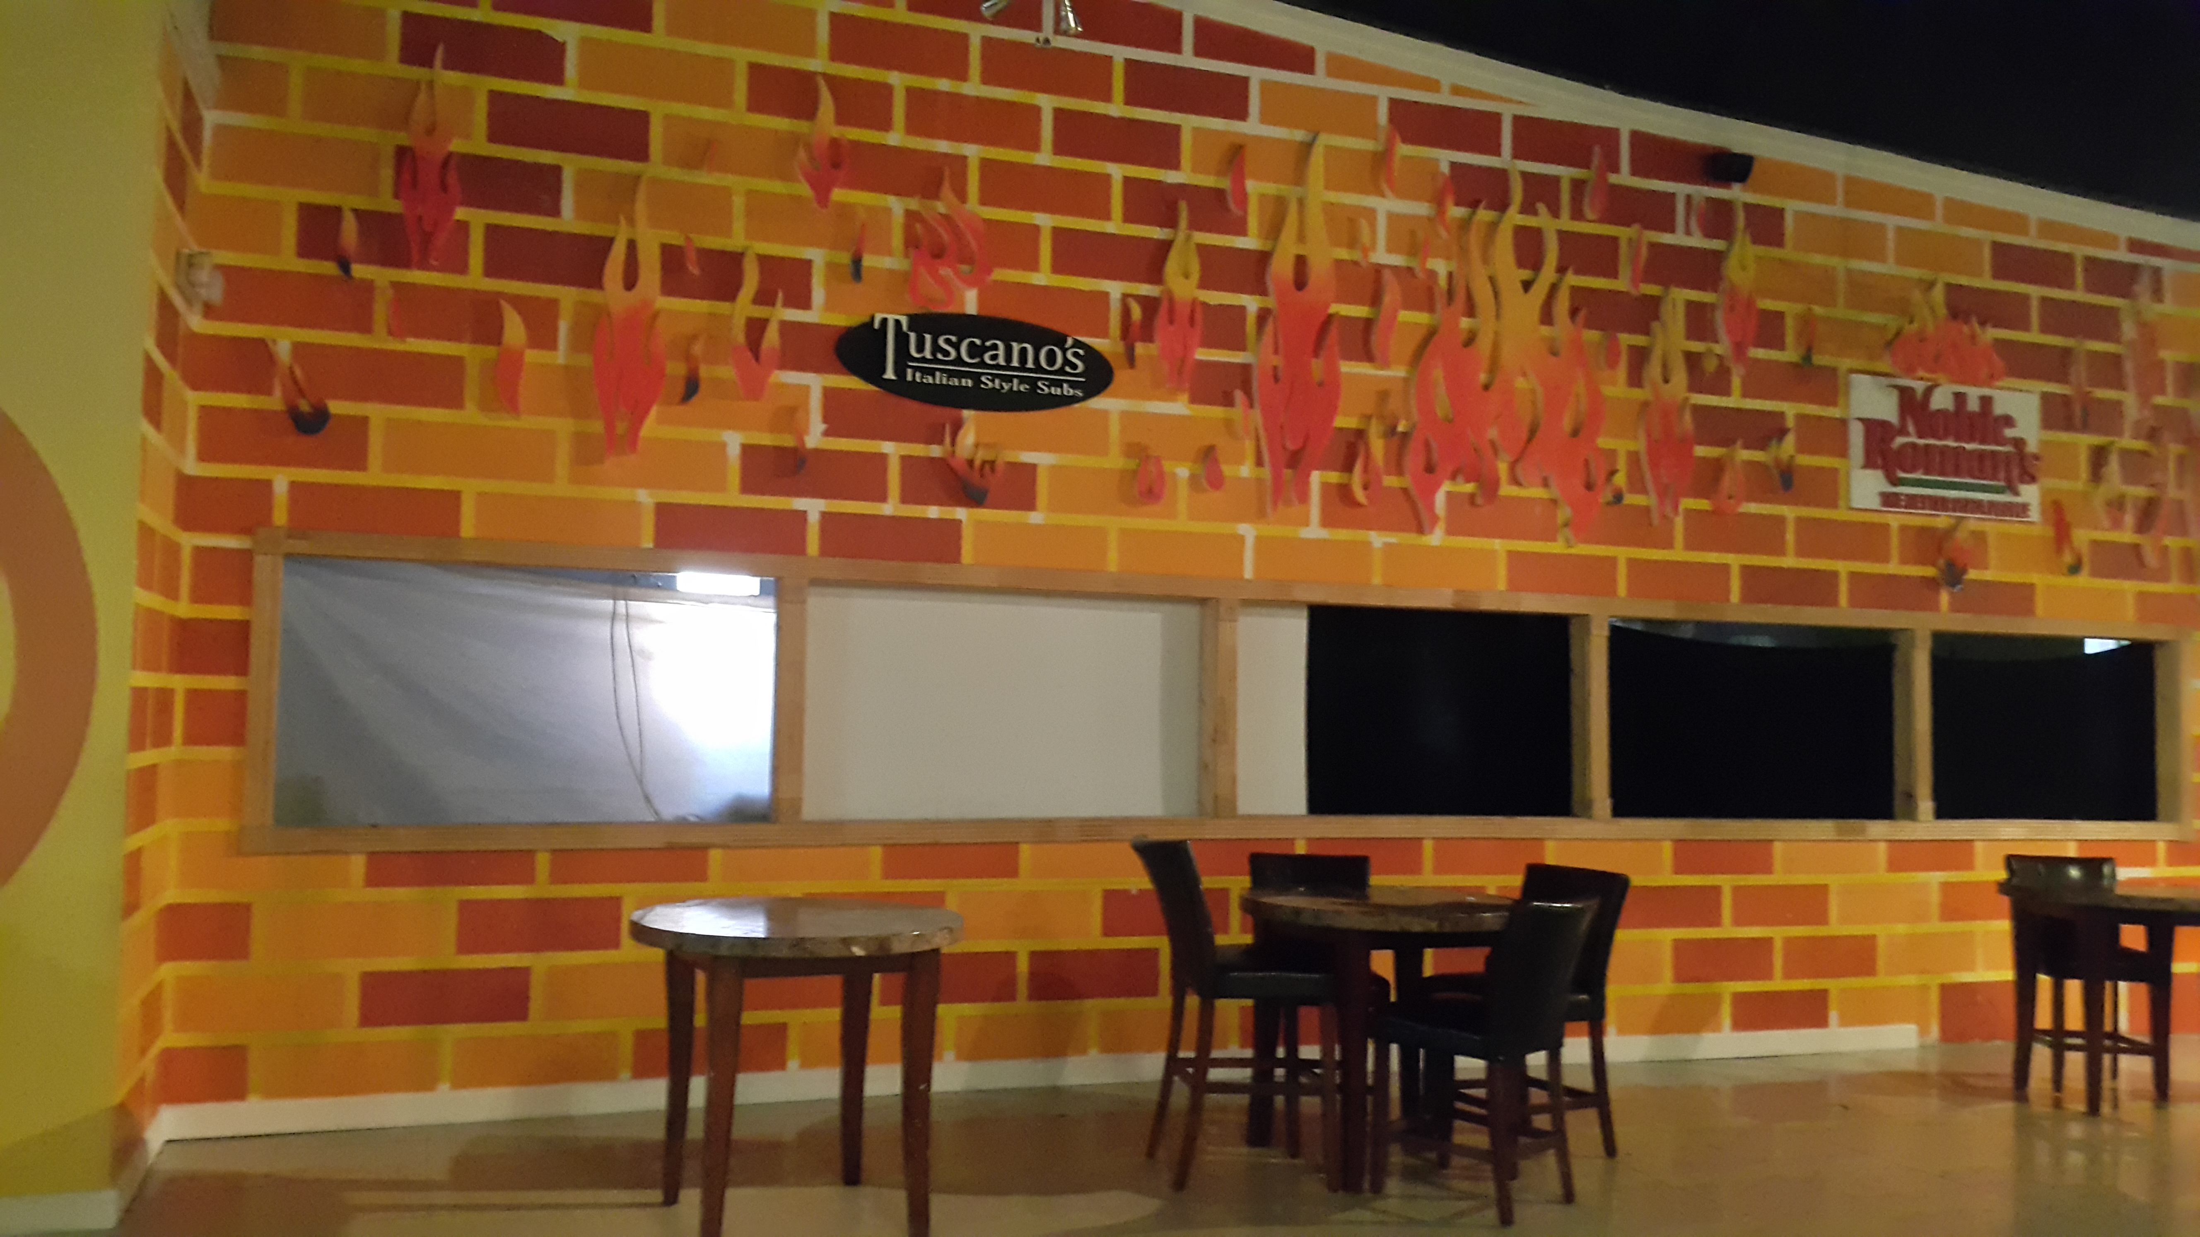This is Mario’s failed attempted at a Multiple F&B offerings approach:
A Short-lived Ice-Cream Parlor
Two Food Franchises that never opened
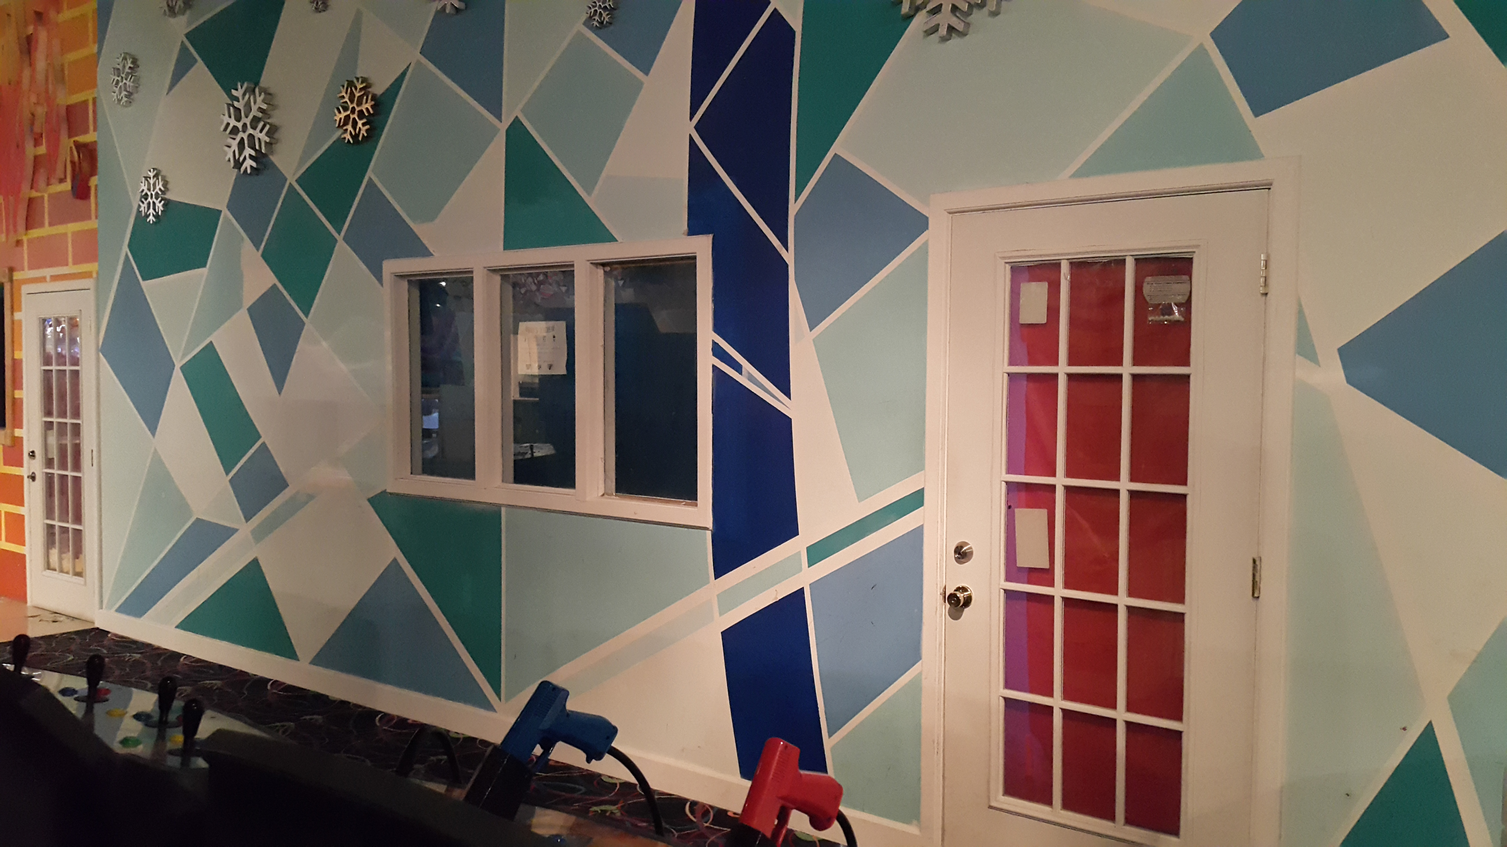
6/3/15
6/3/15
All three of these entities are improperly placed in the arcade without proper signage.
Proper Secondary Product Offering
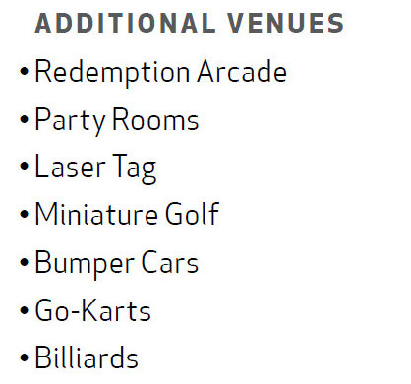The final critical component for long term viability is a correctly balanced product mix to compliment the main attraction.
This is important for:
- Decreasing customer frustrations during wait times for the main attraction
- Increase the customer base during off seasons of the main attraction.
- Providing amenities to maximize party revenues
Ultimately, this is also where the Mario’s business model truly struggles. Its secondary products included:
- A Go-Kart Track
- A Skating Rink
- An Arcade with adjacent party rooms

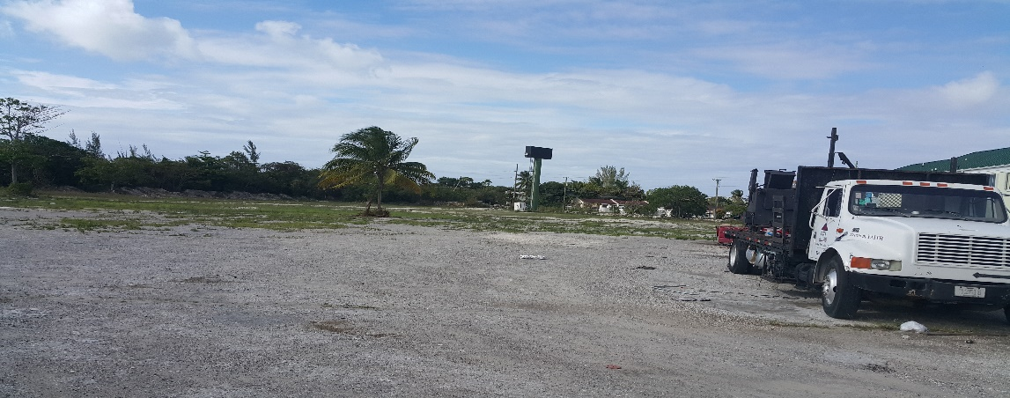
The Go-Kart Track was poorly advertised and implemented. It since has failed. This is the remnants of the same.
6/3/15

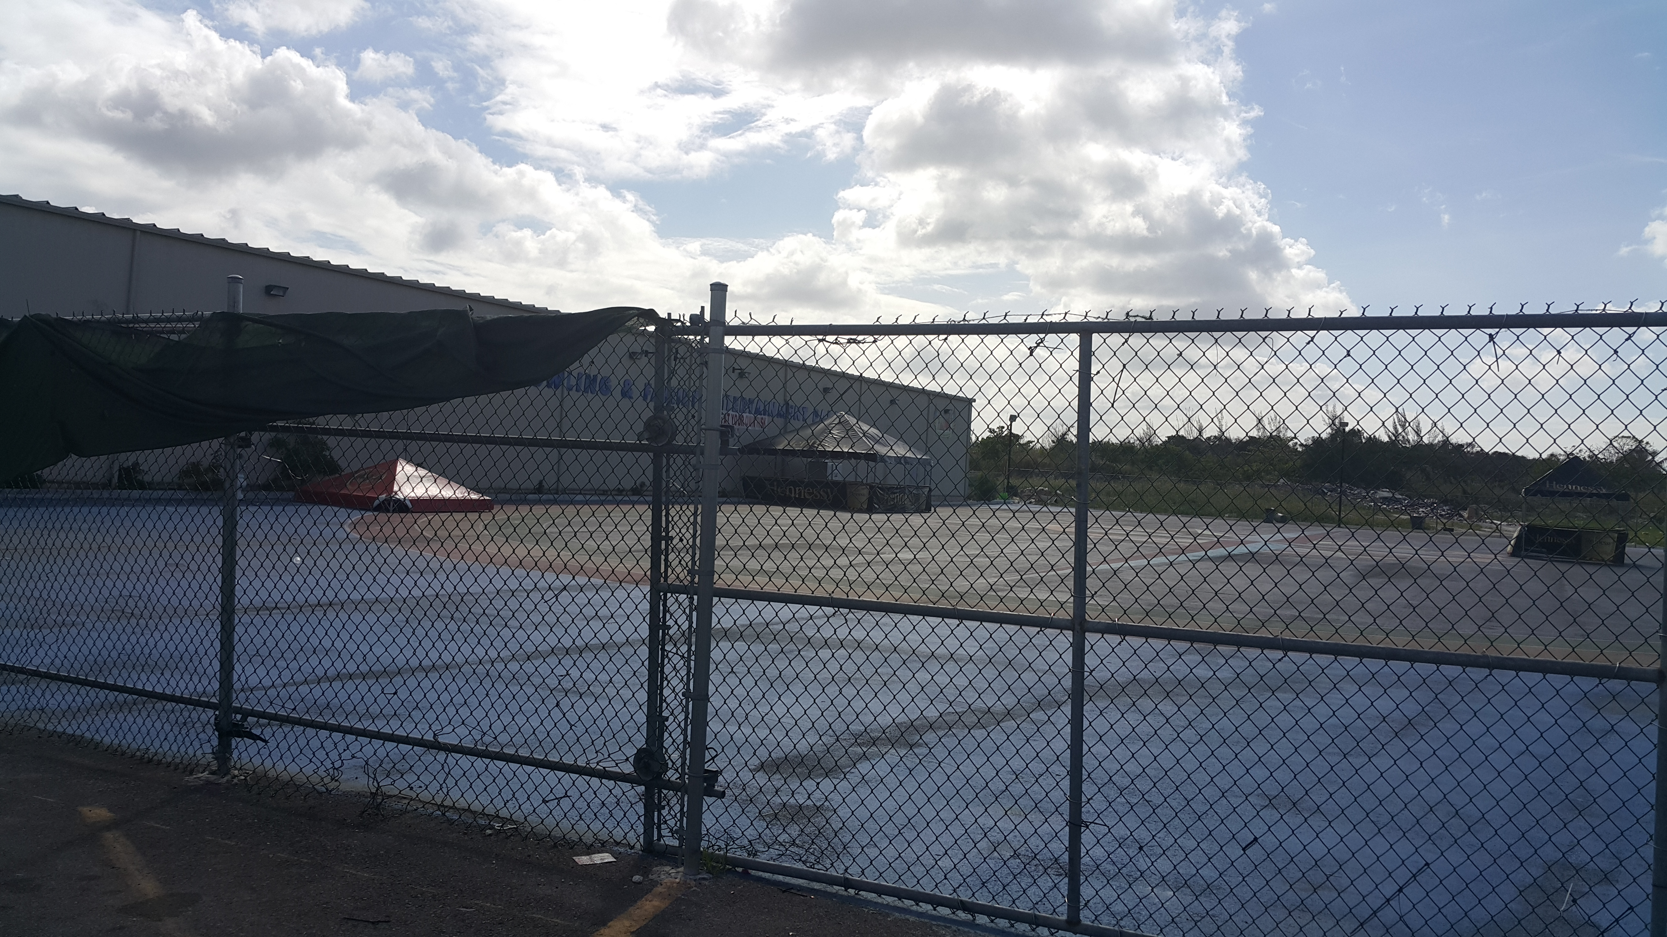The Skating Rink is not doing great business and only available on weekends. To put this into context; observe the rink on a major public holiday with kids out of school during the Easter holiday in April 2015 (4-day Weekend).
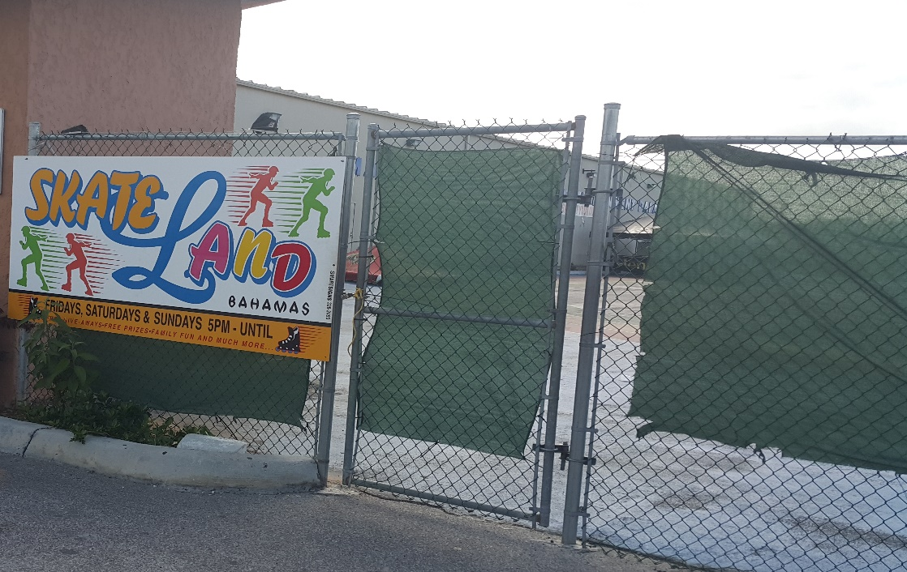
6/3/15
6/3/15

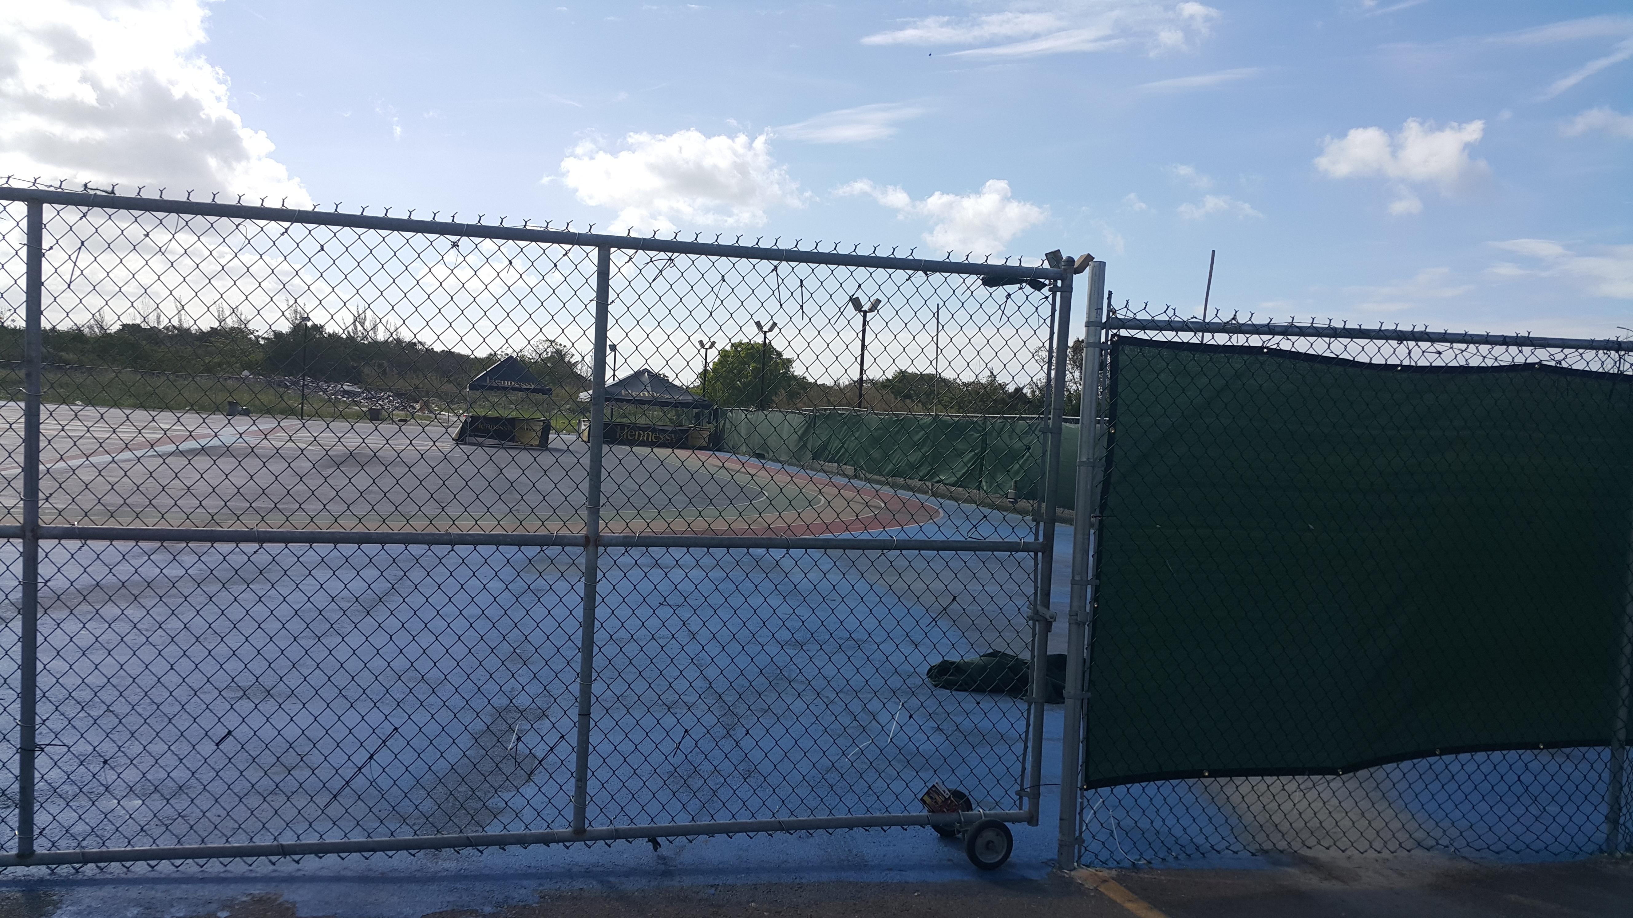To add insult to injury the Skate Rink is surrounded by a tarp which hides it from public viewing, hence retarding possible future sales.
6/3/15
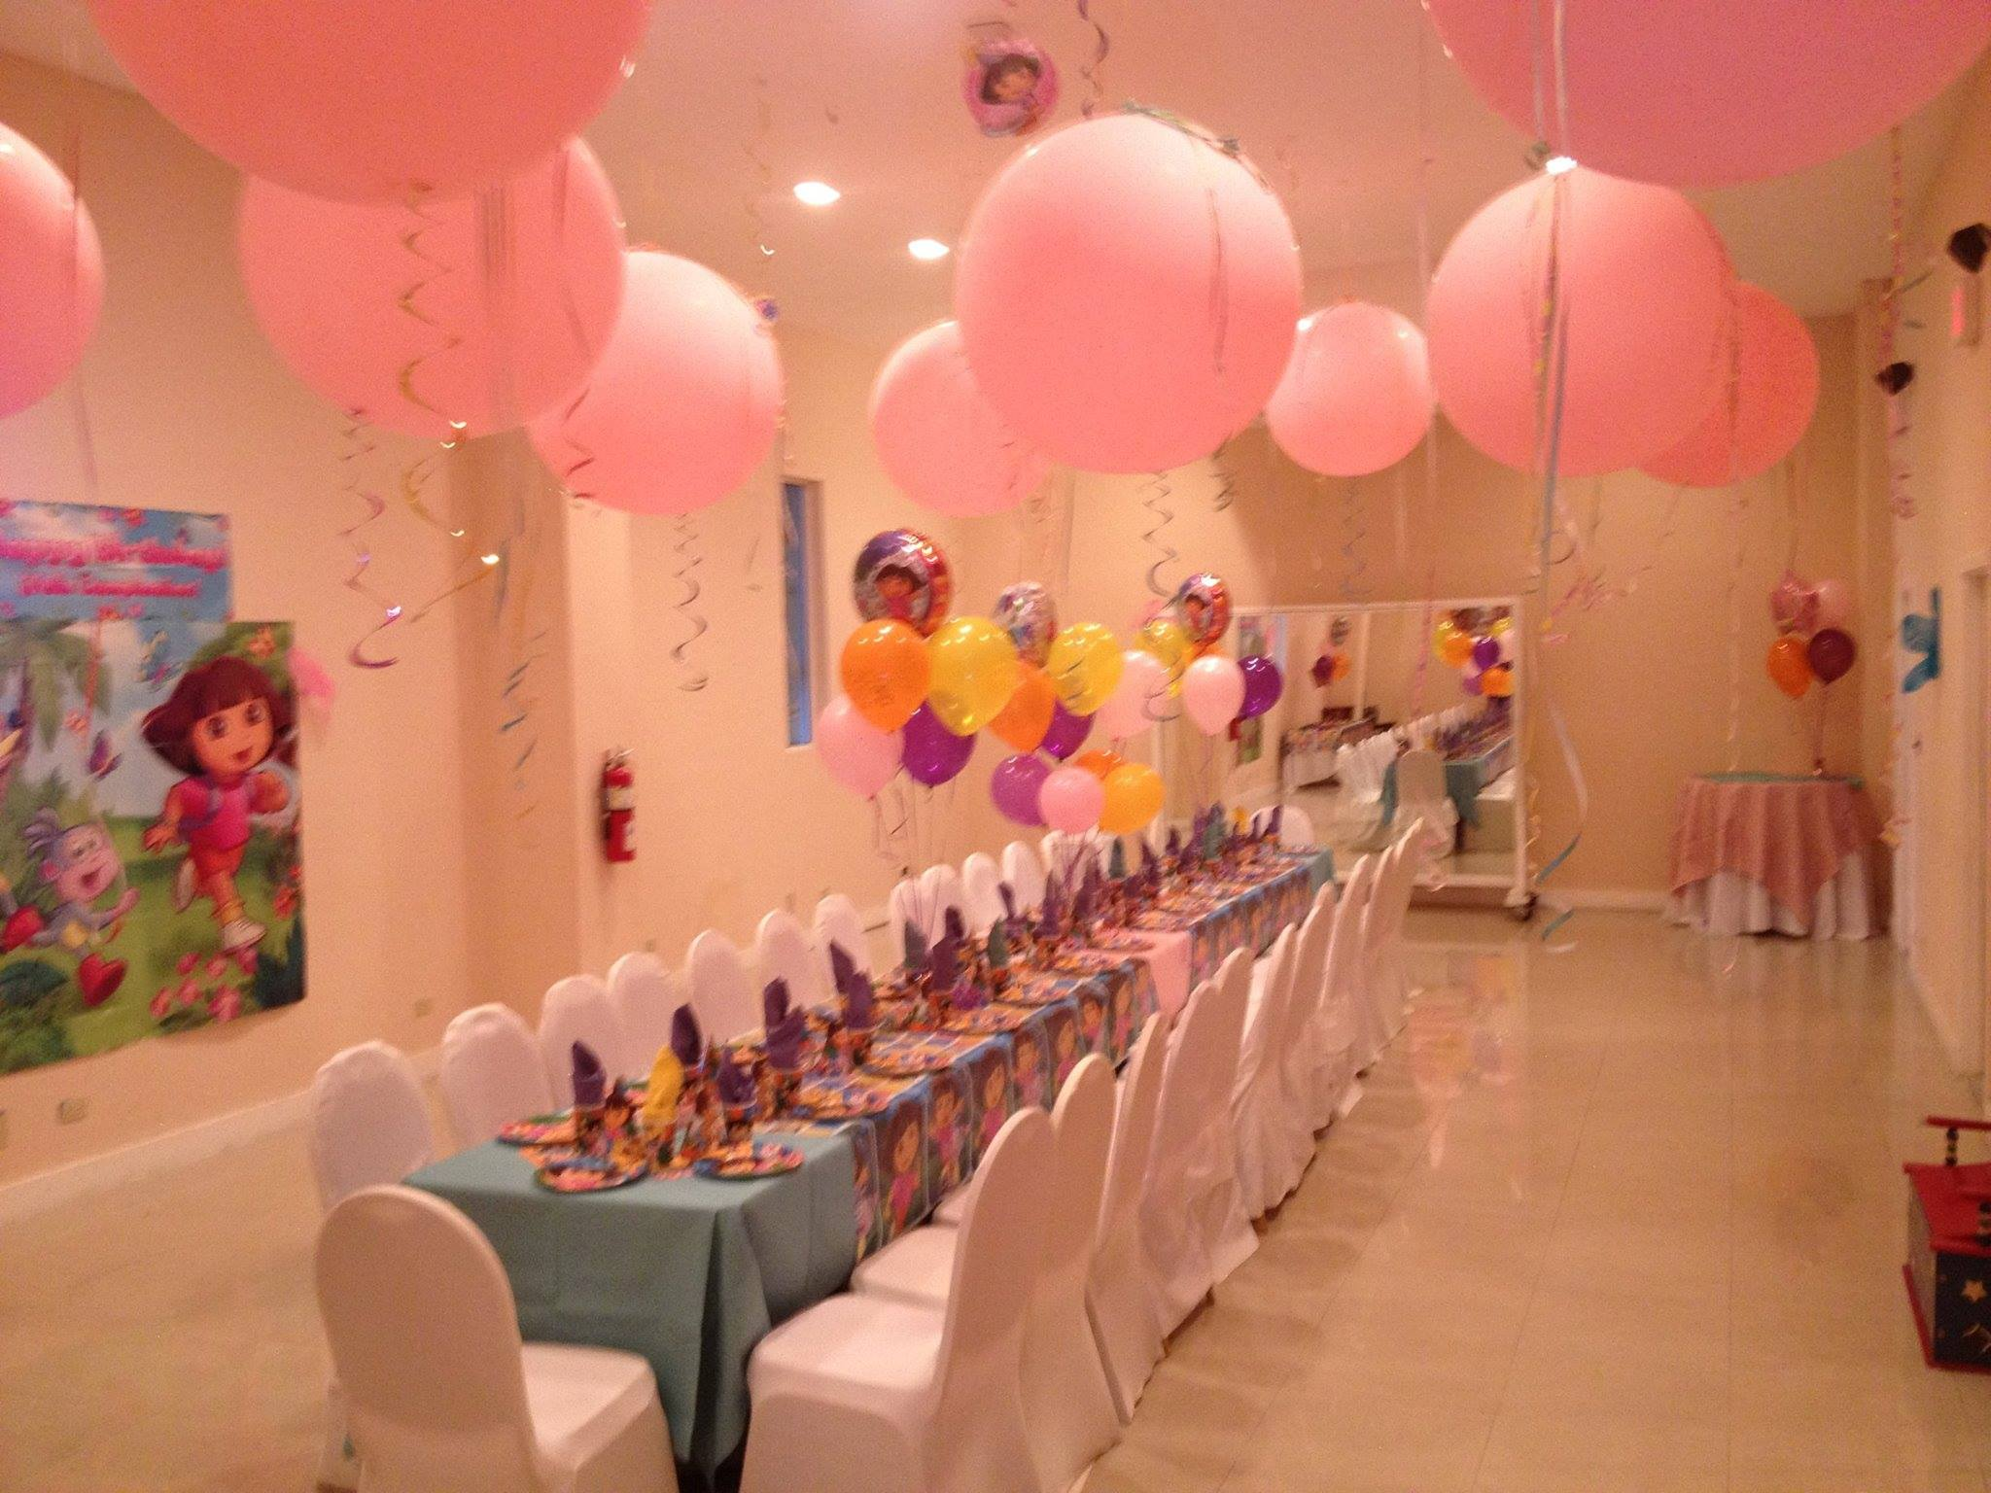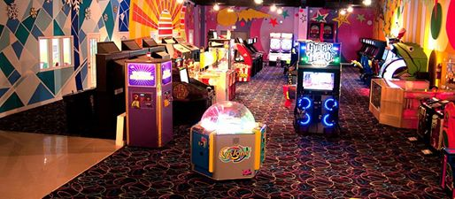The arcade and party/special events revenue are the major secondary sources of income for Mario’s from an entire product mix portfolio.

Long Term Viability of Mario’s Bowling Challenged
The anchor tenant, of the Summer Winds Plaza was Robin Hood Food store. The same provided a great synergistic relationship to Mario’s.
Why?
Robin Hood’s high traffic flow of shoppers brought a diverse crowd. This exposure to a different client pool kept Mario’s in the forefront of the minds of potential new customers. This hence mitigated so many of the fundamental flaws of the bowling establishment.
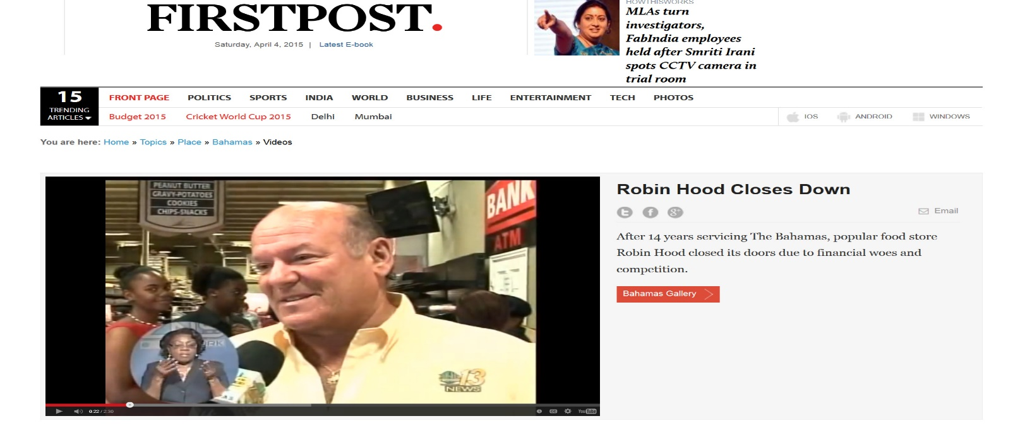
Then fiscal tragedy struck in 2012………….

Citing loses of over $3.5 million the previous year, Robin Hood Food store closes in spring 2012.
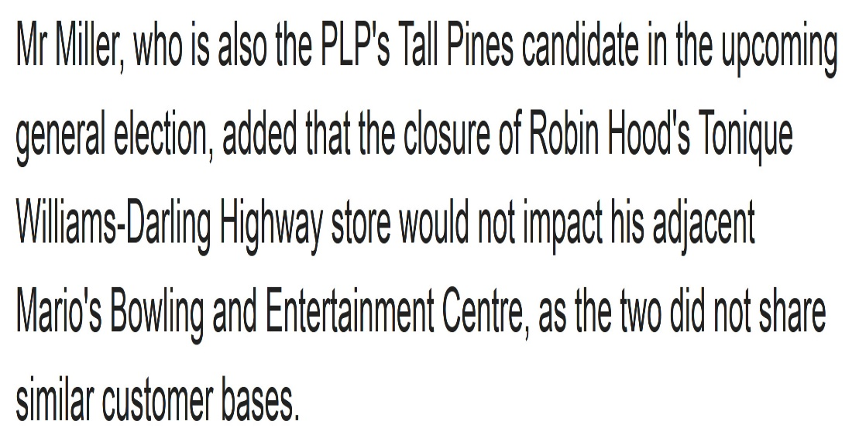
At this juncture, the importance of Robin Hood as well as the business dynamic between companies is misunderstood by Mario’s Management.
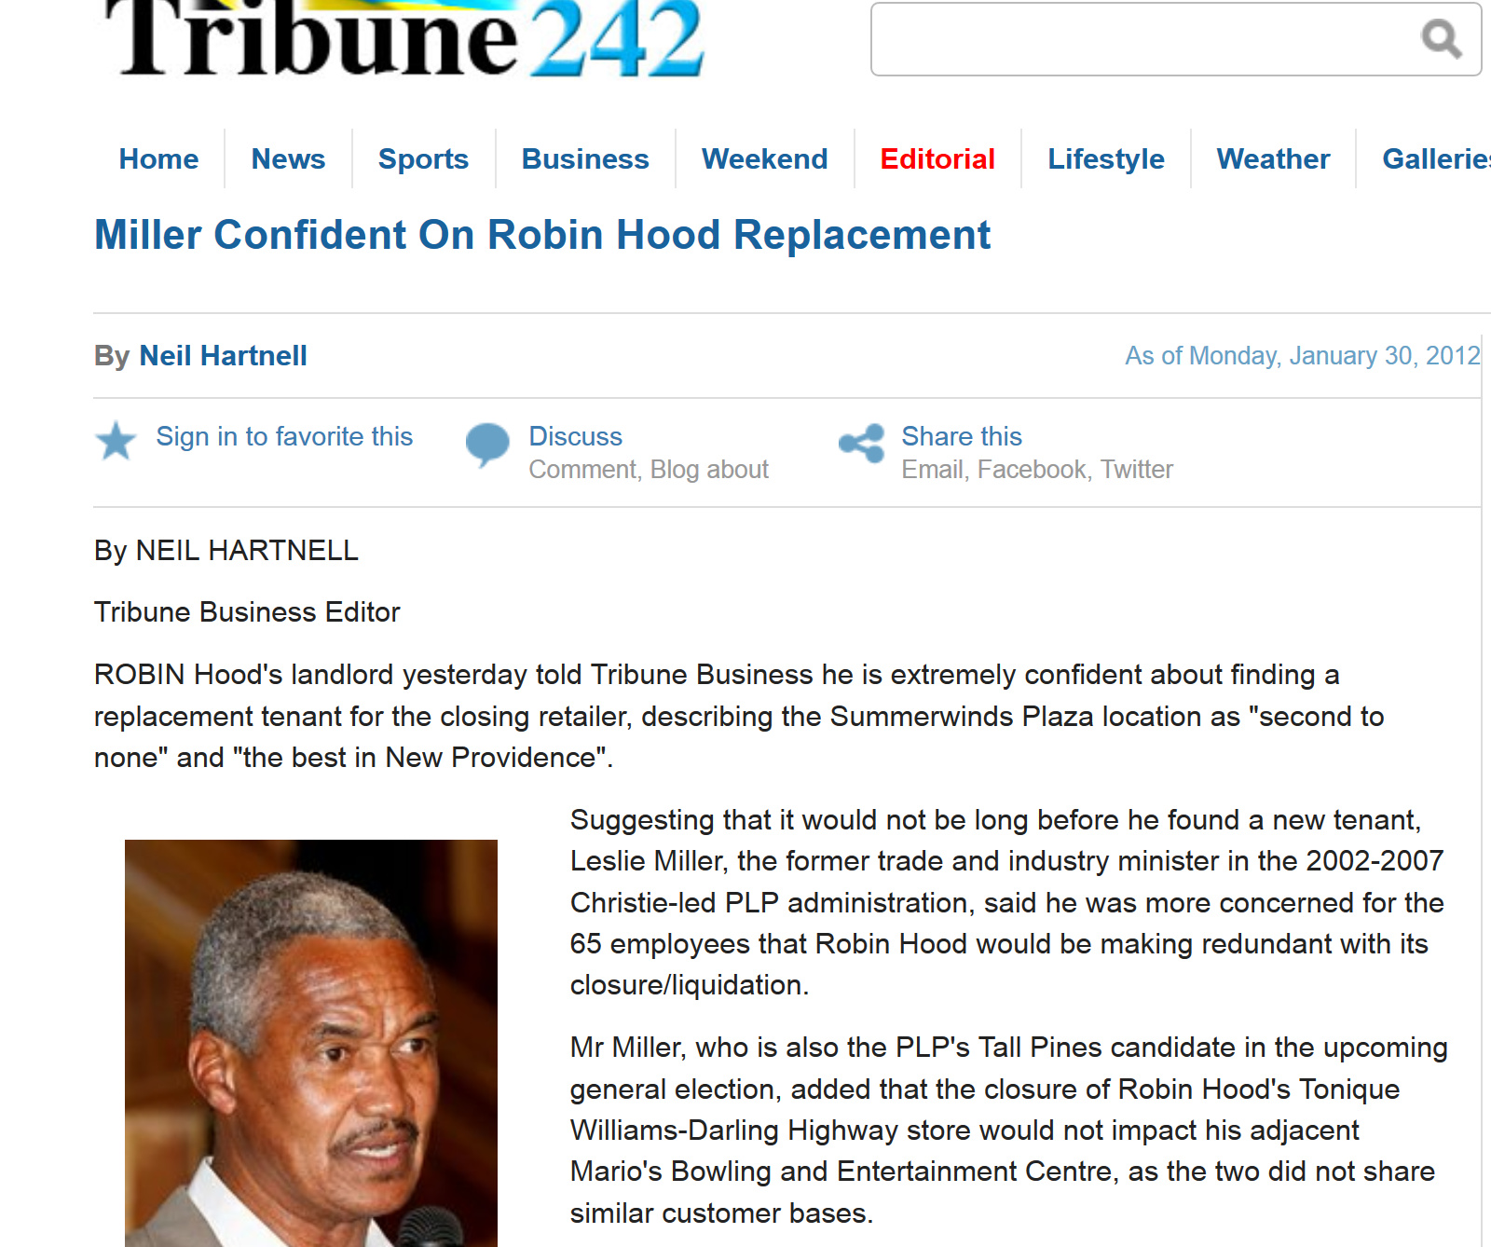Management overestimated the true value of their location, specifically when taking into account poor roadside visibility.

Fast-forward to 2015:
Copper thieves have completely destroyed the unoccupied Robin Hood Store Shell.

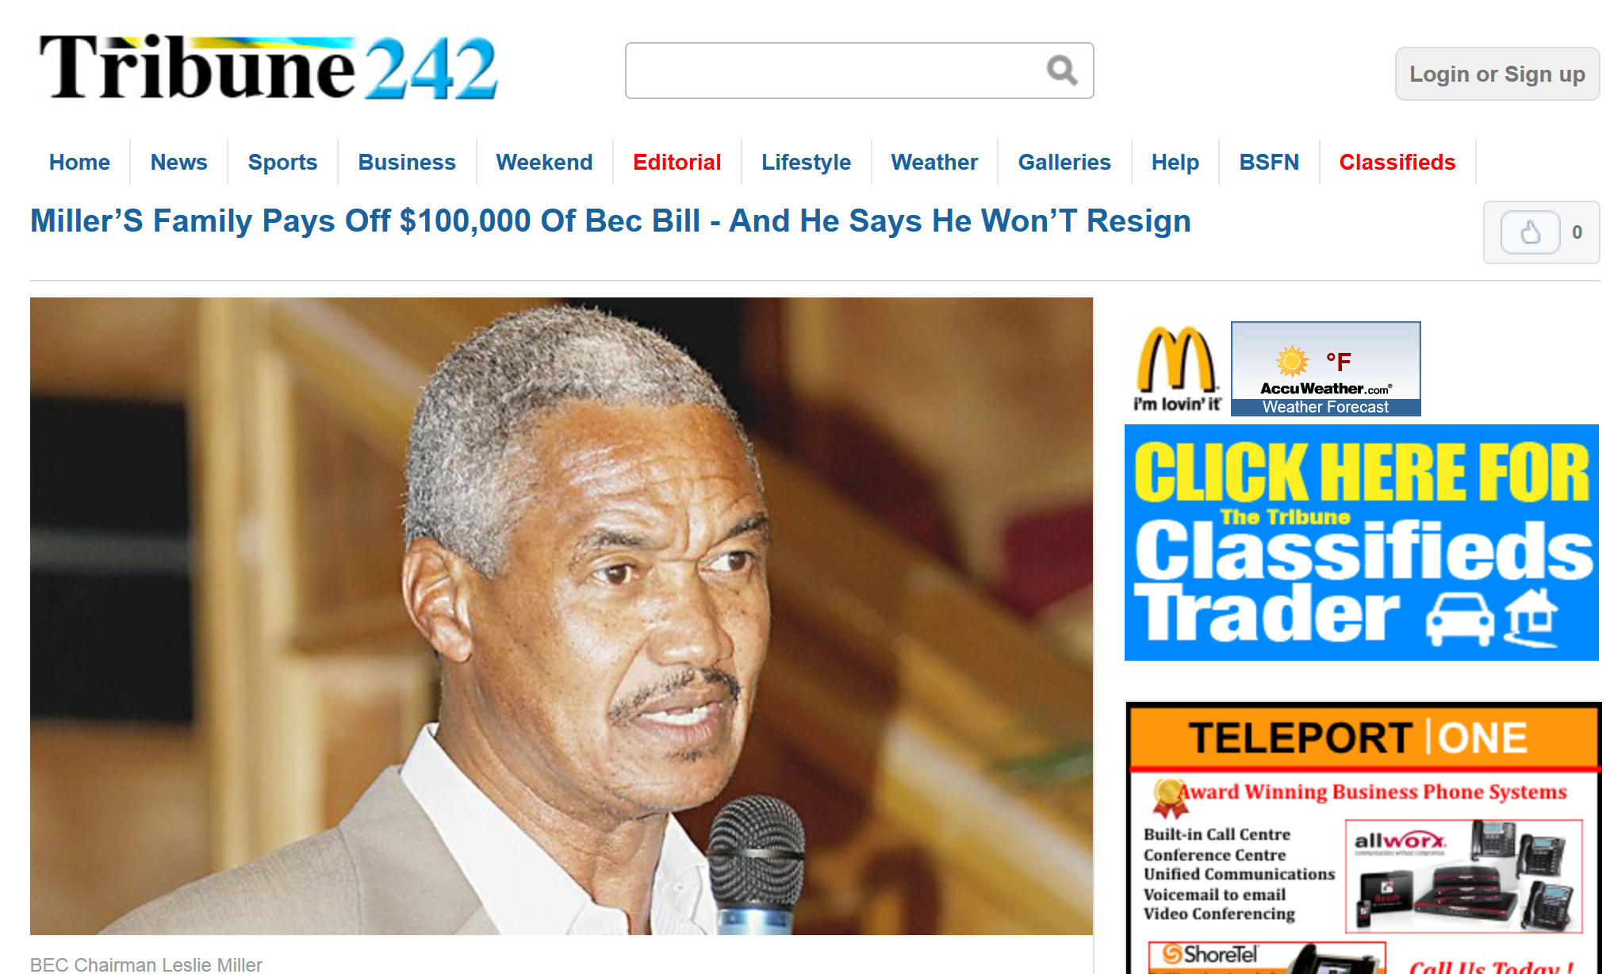Mario’s financial woes have been well documented.

The effects of losing their anchor attraction revealed the flaws in their business model. Currently, besides parties and special events, only bowlers and kids now frequent Mario’s.

Hypothesis
The issues that Mario’s experienced are not a bowling related phenomenon. These difficulties are more associated with Family Entertainment Centers and their operational ratios.
Stand-alone entities will struggle with long term viability without the following:
- Multiple Food Choices
- A Potent Product Mix
- Proper Location Visibility
Depending on a single customer base for a FEC may bring short term success; however sustainability will be compromised. Development of the Business Model of the Showcase reflects this understanding.
The project’s newness and roadside visibility may be strong components for early success. Nevertheless appropriate structural and philosophical infrastructure are now in place to guarantee long term viability.

